Chapter 8, Solution 28.
A series RLC circuit is described by

L[d²i/dt²] + R[di/dt] + i/C = 10
Find the response when L = 0.5 H, R = 4 Ω, and C = 0.2 F. Let 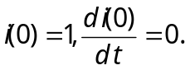
Solution

The characteristic equation is

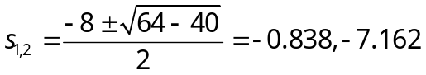
–6.45 and –1.5505

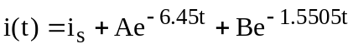

But [i_{s}/C] = 10 or i_{s} = 0.2x10 = 2

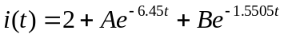

i(0) = 1 = 2 + A + B or A + B = –1 or A = –1–B (1)

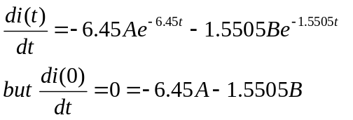 (2)

Solving (1) and (2) gives –6.45(–1–B) – 1.5505B = 0 or (6.45–1.5505)B = –6.45
B = –6.45/(4.9) = –1.3163 and A = –1+1.3163 = 0.3163

A= 0.3163, B= –1.3163
Hence,
i(t) = [2+0.3163e^{–6.45t} –1.3163e^{–1.5505t}] A.

